江苏康尚生物医疗科技有限公司

康尚医疗集团创立于2013年，是一家专注于体外诊断、家庭医疗、移动医疗、宠物医疗以及大健康生态链科技的创新型科技公司。康尚医疗是国内唯一1家专注于基层医疗全系列解决方案的供应商，是第一家进入联合国、世界银行呼吸类产品采购目录的中国企业，国内首创的全血微流控血红蛋白分析仪在全球市场取得重大突破，是唯一进入该领域的中国制造企业。

      公司总部设立在江苏丹阳，并在深圳设立研发中心，在南京设立营销中心，融研发、制造、销售、服务为一体。公司推出的体外诊断系列、家庭健康系列、移动医疗系列、基层互联网医疗系列等几十余款产品，迅速成为万所基层医疗服务机构、百万户家庭的共同选择，产品遍布全球一百多个国家及地区。

     “见证更多欢笑”是康尚公司的使命，为全球用户提供专业、精准、便捷、高效的智能健康产品和服务。

[外诊断](https://www.konsung.com/TWZD)

[便携式干式生化分析仪](https://www.konsung.com/ProductDetail/6731441.html)

[干式生化分析仪](https://www.konsung.com/ProductDetail/6456470.html)

[荧光免疫分析仪](https://www.konsung.com/ProductDetail/6456488.html)

[血红蛋白分析仪](https://www.konsung.com/ProductDetail/6456485.html)

[白细胞分析仪](https://www.konsung.com/ProductDetail/6456453.html)

[尿液分析仪](https://www.konsung.com/ProductDetail/6456455.html)

[家用医疗](https://www.konsung.com/Content/2007326.html)

[医用设备](https://www.konsung.com/Product/475895.html)

[动物医疗](https://www.konsung.com/dwyl)

[[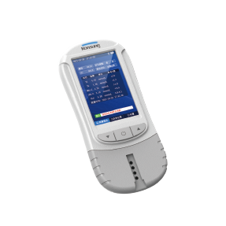](https://www.konsung.com/ProductDetail/6731441.html)](https://www.konsung.com/ProductDetail/6731441.html" \t "_blank)

[便携式干式生化分析仪](https://www.konsung.com/ProductDetail/6731441.html" \t "_blank)

[[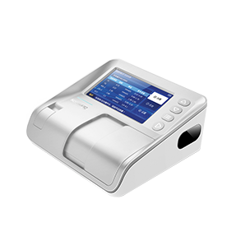](https://www.konsung.com/ProductDetail/6456470.html)](https://www.konsung.com/ProductDetail/6456470.html" \t "_blank)

[干式生化分析仪](https://www.konsung.com/ProductDetail/6456470.html" \t "_blank)

[[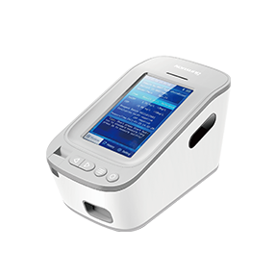](https://www.konsung.com/ProductDetail/6456488.html)](https://www.konsung.com/ProductDetail/6456488.html" \t "_blank)

[时间分辨荧光免疫分析仪](https://www.konsung.com/ProductDetail/6456488.html" \t "_blank)

[[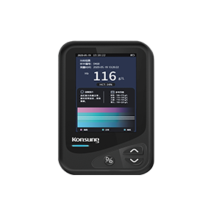](https://www.konsung.com/ProductDetail/6456485.html)](https://www.konsung.com/ProductDetail/6456485.html" \t "_blank)

[血红蛋白分析仪](https://www.konsung.com/ProductDetail/6456485.html" \t "_blank)

[[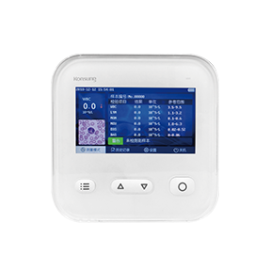](https://www.konsung.com/ProductDetail/6456453.html)](https://www.konsung.com/ProductDetail/6456453.html" \t "_blank)

[白细胞分析仪](https://www.konsung.com/ProductDetail/6456453.html" \t "_blank)

[[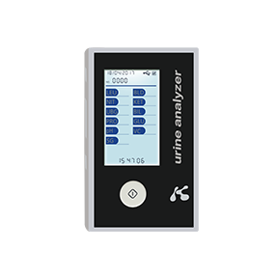](https://www.konsung.com/ProductDetail/6456455.html)](https://www.konsung.com/ProductDetail/6456455.html" \t "_blank)

[半自动尿液分析仪](https://www.konsung.com/ProductDetail/6456455.html" \t "_blank)

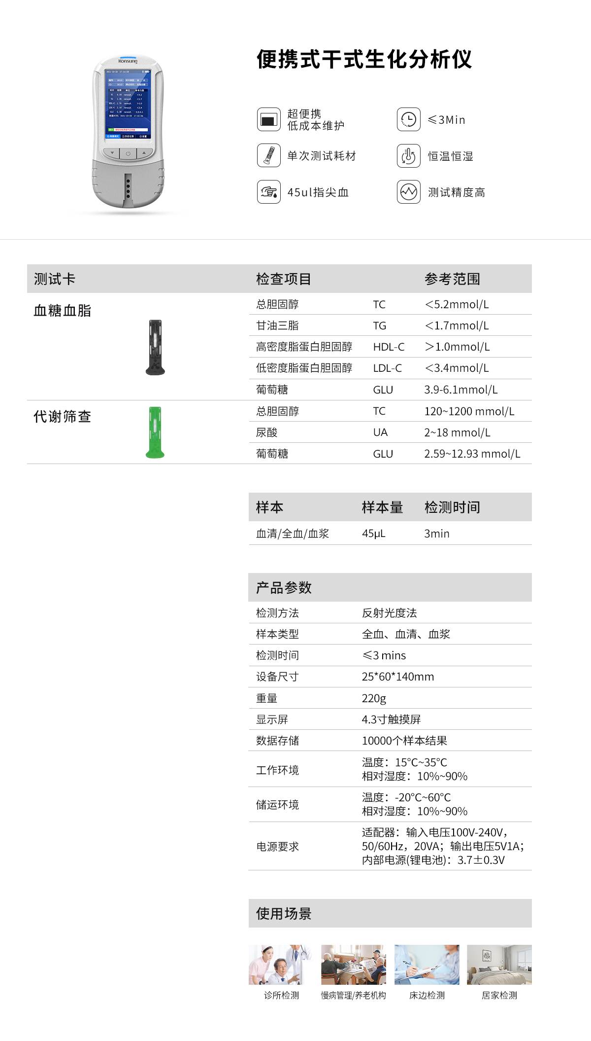

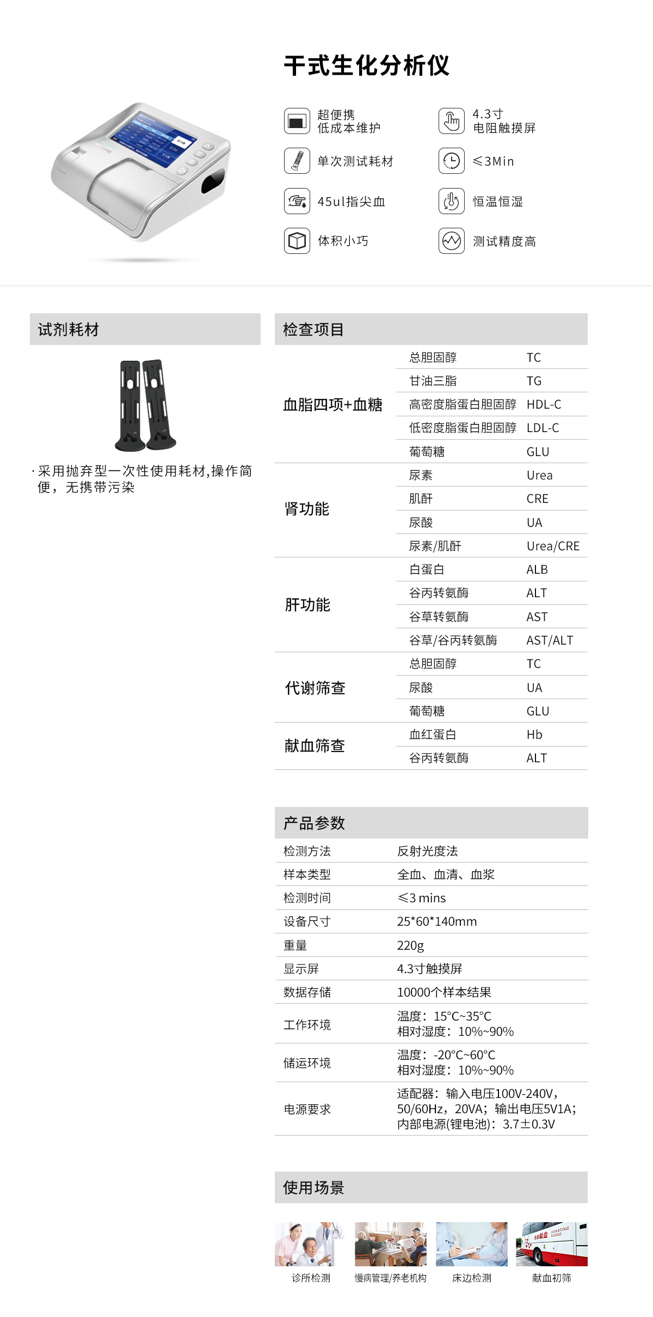

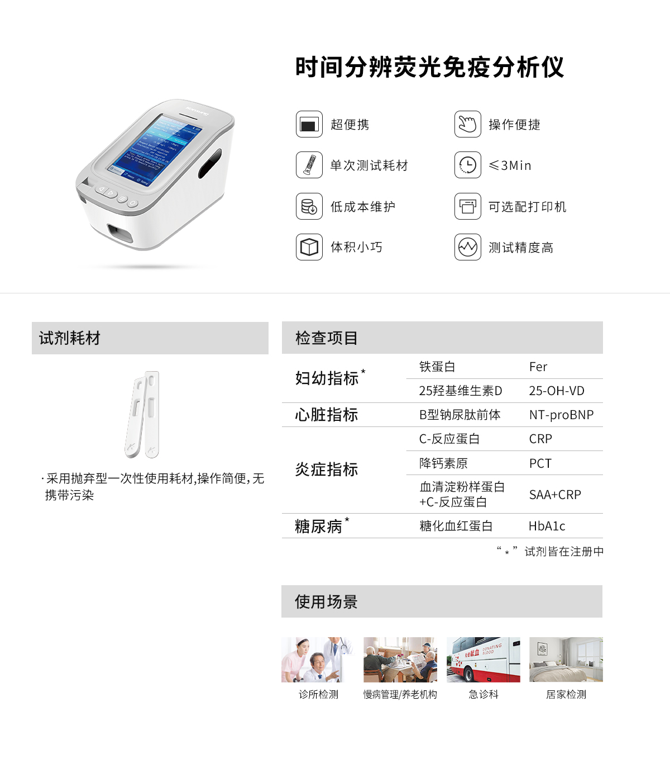

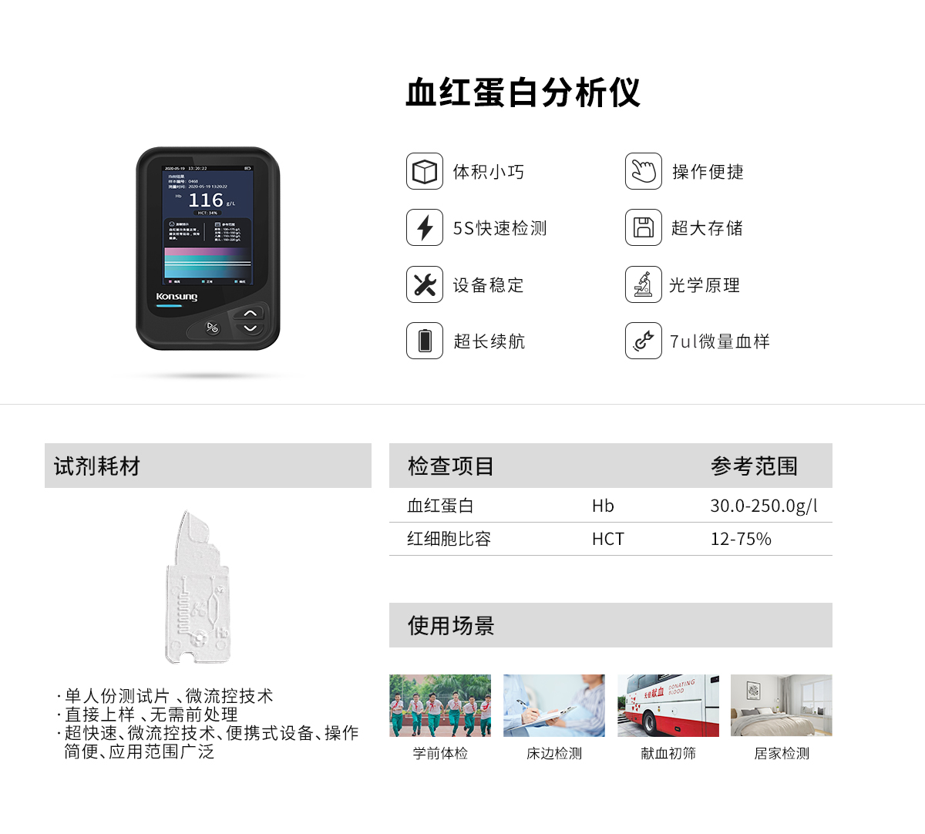

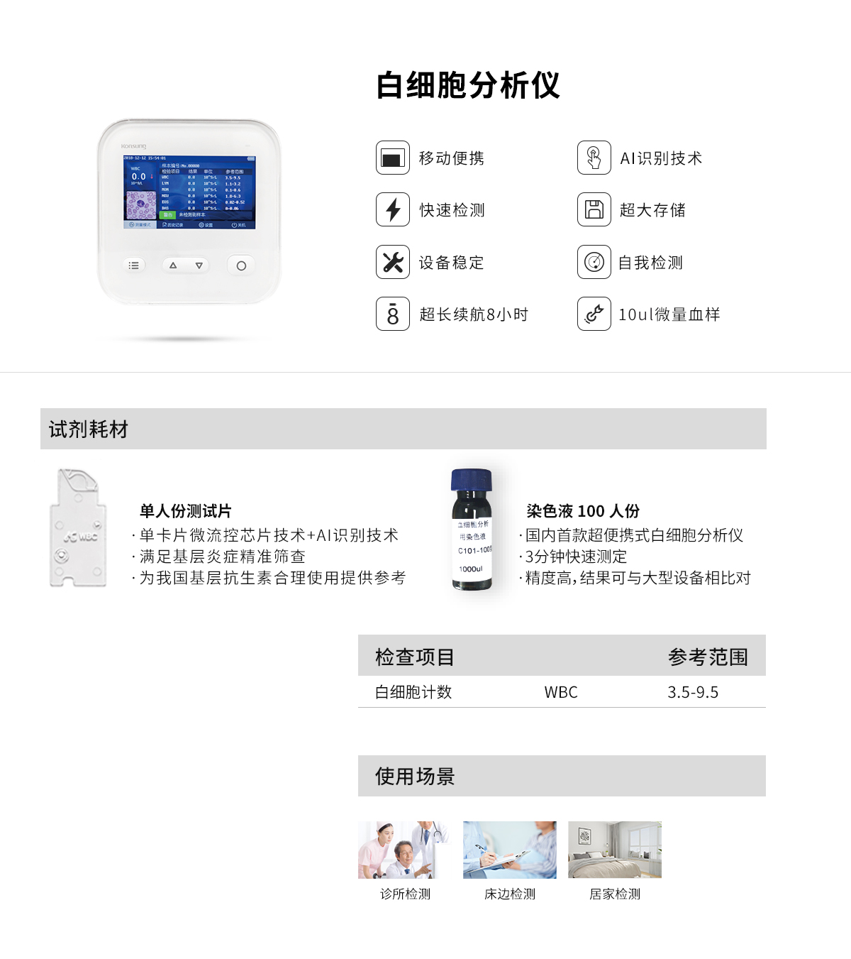

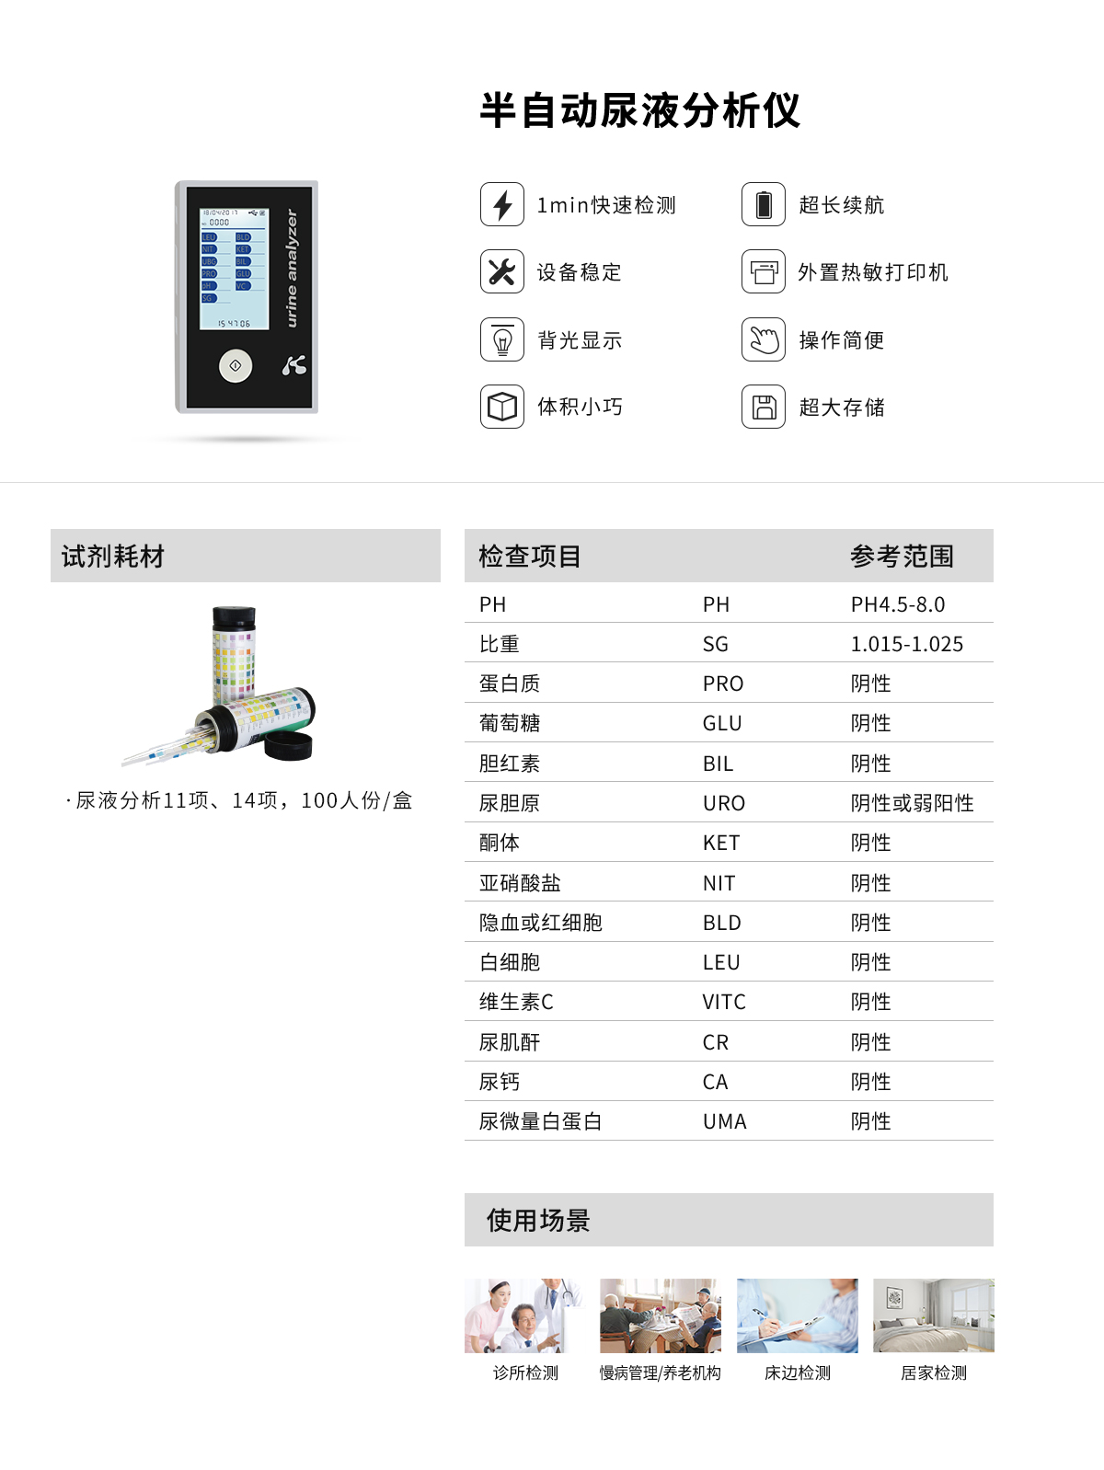

[体外诊断](https://www.konsung.com/TWZD)

[家用医疗](https://www.konsung.com/Content/2007326.html)

[呼吸机](https://www.konsung.com/Product/497639.html)

[制氧机](https://www.konsung.com/Product/477715.html)

[血氧仪](https://www.konsung.com/Product/477716.html)

[血压计](https://www.konsung.com/Product/477718.html)

[医用设备](https://www.konsung.com/Product/475895.html)

[动物医疗](https://www.konsung.com/dwyl)

[[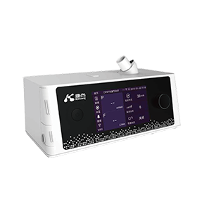](https://www.konsung.com/ProductDetail/6699724.html)](https://www.konsung.com/ProductDetail/6699724.html" \t "_blank)

[单水平正压通气治疗仪DM28-20A-W](https://www.konsung.com/ProductDetail/6699724.html" \t "_blank)

[[](https://www.konsung.com/ProductDetail/7005550.html)](https://www.konsung.com/ProductDetail/7005550.html" \t "_blank)

[单水平正压通气治疗仪DM28-20A-WP](https://www.konsung.com/ProductDetail/7005550.html" \t "_blank)

[[](https://www.konsung.com/ProductDetail/6699726.html)](https://www.konsung.com/ProductDetail/6699726.html" \t "_blank)

[无创呼吸机DM28-25SA-BP](https://www.konsung.com/ProductDetail/6699726.html" \t "_blank)

[[](https://www.konsung.com/ProductDetail/7005555.html)](https://www.konsung.com/ProductDetail/7005555.html" \t "_blank)

[无创呼吸机 DM28-25ST-BP](https://www.konsung.com/ProductDetail/7005555.html" \t "_blank)

[[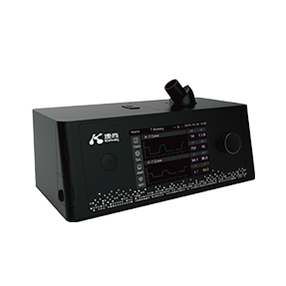](https://www.konsung.com/ProductDetail/6699728.html)](https://www.konsung.com/ProductDetail/6699728.html" \t "_blank)

[无创呼吸机DM28-30STA-BP](https://www.konsung.com/ProductDetail/6699728.html" \t "_blank)

[[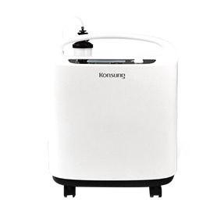](https://www.konsung.com/ProductDetail/6757695.html)](https://www.konsung.com/ProductDetail/6757695.html" \t "_blank)

[KSW-3/3N/5/5N医用级制氧机（静音款）](https://www.konsung.com/ProductDetail/6757695.html" \t "_blank)

[[](https://www.konsung.com/ProductDetail/6456311.html)](https://www.konsung.com/ProductDetail/6456311.html" \t "_blank)

[KSW-3/3N/5/5N医用制氧机](https://www.konsung.com/ProductDetail/6456311.html" \t "_blank)

[[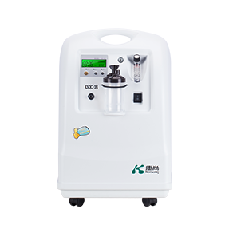](https://www.konsung.com/ProductDetail/6456305.html)](https://www.konsung.com/ProductDetail/6456305.html" \t "_blank)

[KSOC-3/3N/5/5N医用制氧机](https://www.konsung.com/ProductDetail/6456305.html" \t "_blank)

[[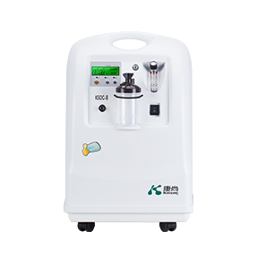](https://www.konsung.com/ProductDetail/6760634.html)](https://www.konsung.com/ProductDetail/6760634.html" \t "_blank)

[KSOC-8/8N医用制氧机](https://www.konsung.com/ProductDetail/6760634.html" \t "_blank)

[[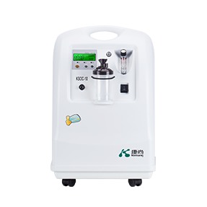](https://www.konsung.com/ProductDetail/6757845.html)](https://www.konsung.com/ProductDetail/6757845.html" \t "_blank)

[KSOC-10/10N医用制氧机](https://www.konsung.com/ProductDetail/6757845.html" \t "_blank)

[[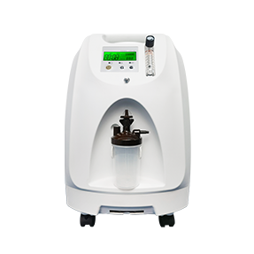](https://www.konsung.com/ProductDetail/6456313.html)](https://www.konsung.com/ProductDetail/6456313.html" \t "_blank)

[KSN-3T/3M/5T/5M医用制氧机](https://www.konsung.com/ProductDetail/6456313.html" \t "_blank)

[[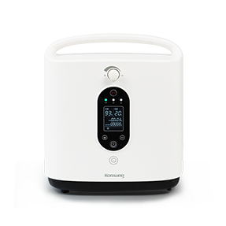](https://www.konsung.com/ProductDetail/6456339.html)](https://www.konsung.com/ProductDetail/6456339.html" \t "_blank)

[KSH-1/1T/1M家用保健制氧机](https://www.konsung.com/ProductDetail/6456339.html" \t "_blank)

[[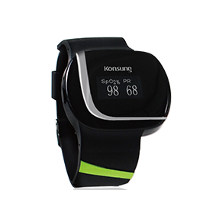](https://www.konsung.com/ProductDetail/6456412.html)](https://www.konsung.com/ProductDetail/6456412.html" \t "_blank)

[SONOSAT-W01LT腕式血氧仪](https://www.konsung.com/ProductDetail/6456412.html" \t "_blank)

[[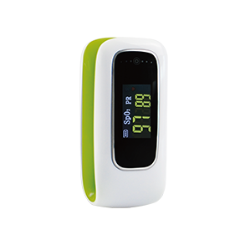](https://www.konsung.com/ProductDetail/6456414.html)](https://www.konsung.com/ProductDetail/6456414.html" \t "_blank)

[SONOSAT-F01T指夹式血氧仪](https://www.konsung.com/ProductDetail/6456414.html" \t "_blank)

[[](https://www.konsung.com/ProductDetail/6456416.html)](https://www.konsung.com/ProductDetail/6456416.html" \t "_blank)

[SONOSAT-F01LT指夹式血氧仪（蓝牙）](https://www.konsung.com/ProductDetail/6456416.html" \t "_blank)

[体外诊断](https://www.konsung.com/TWZD)

[家用医疗](https://www.konsung.com/Content/2007326.html)

[医用设备](https://www.konsung.com/Product/475895.html)

[健康一体机](https://www.konsung.com/Product/499485.html)

[多参数监护仪](https://www.konsung.com/ProductDetail/6456447.html)

[动物医疗](https://www.konsung.com/dwyl)

[[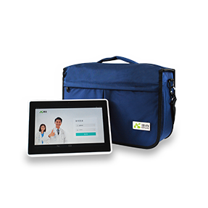](https://www.konsung.com/ProductDetail/6456537.html)](https://www.konsung.com/ProductDetail/6456537.html" \t "_blank)

[HES-M社区服务智能随访包](https://www.konsung.com/ProductDetail/6456537.html" \t "_blank)

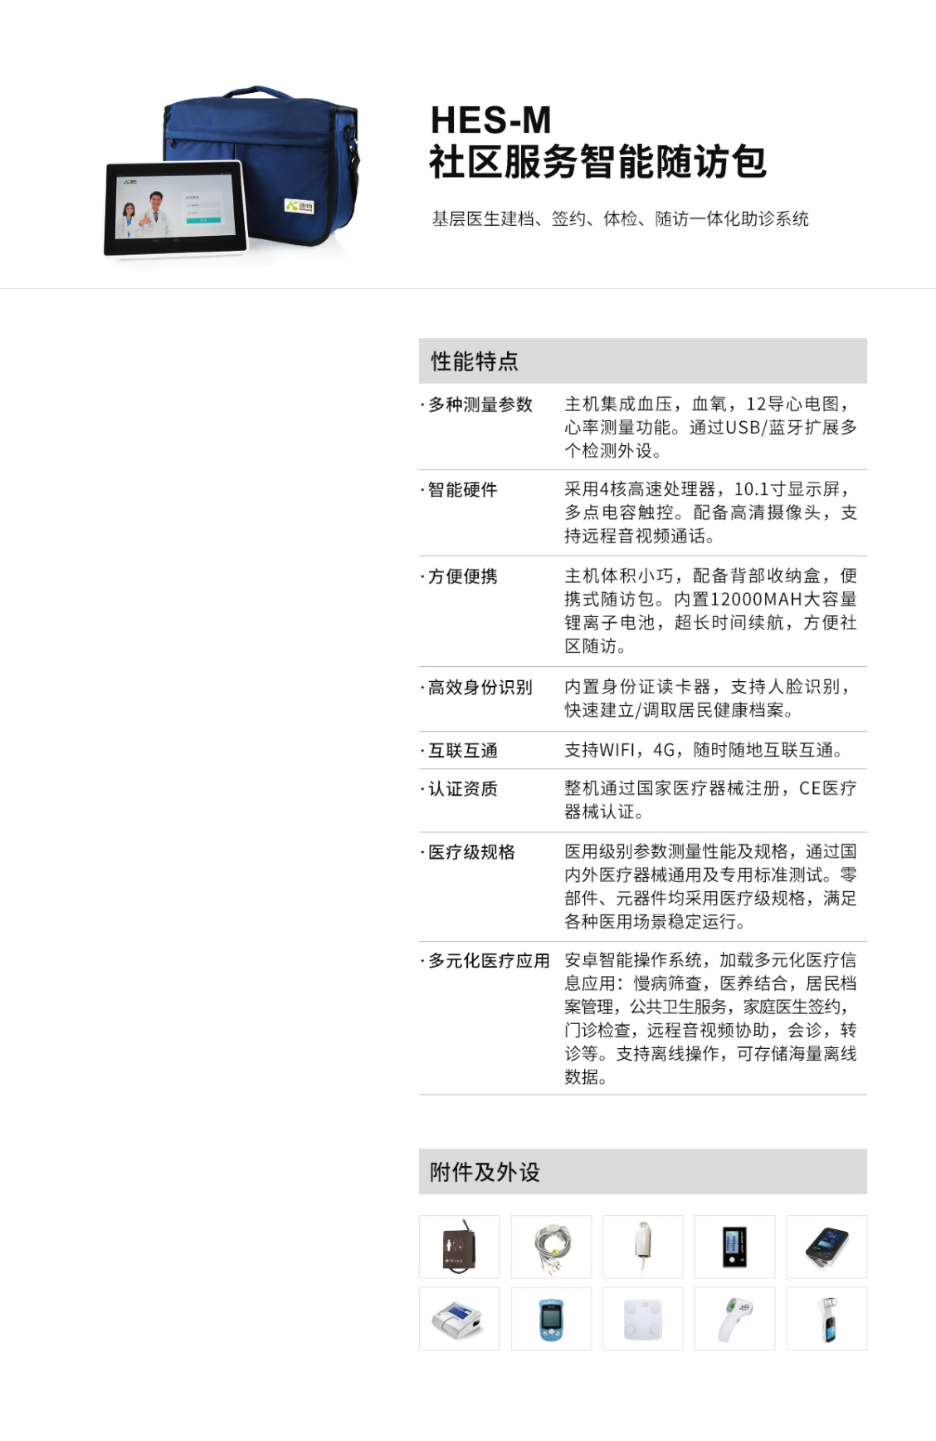

[[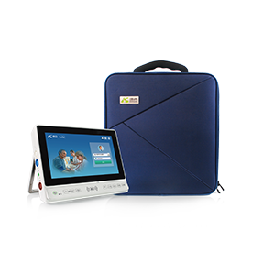](https://www.konsung.com/ProductDetail/6456493.html)](https://www.konsung.com/ProductDetail/6456493.html" \t "_blank)

[HES基层门诊医疗信息化终端](https://www.konsung.com/ProductDetail/6456493.html" \t "_blank)

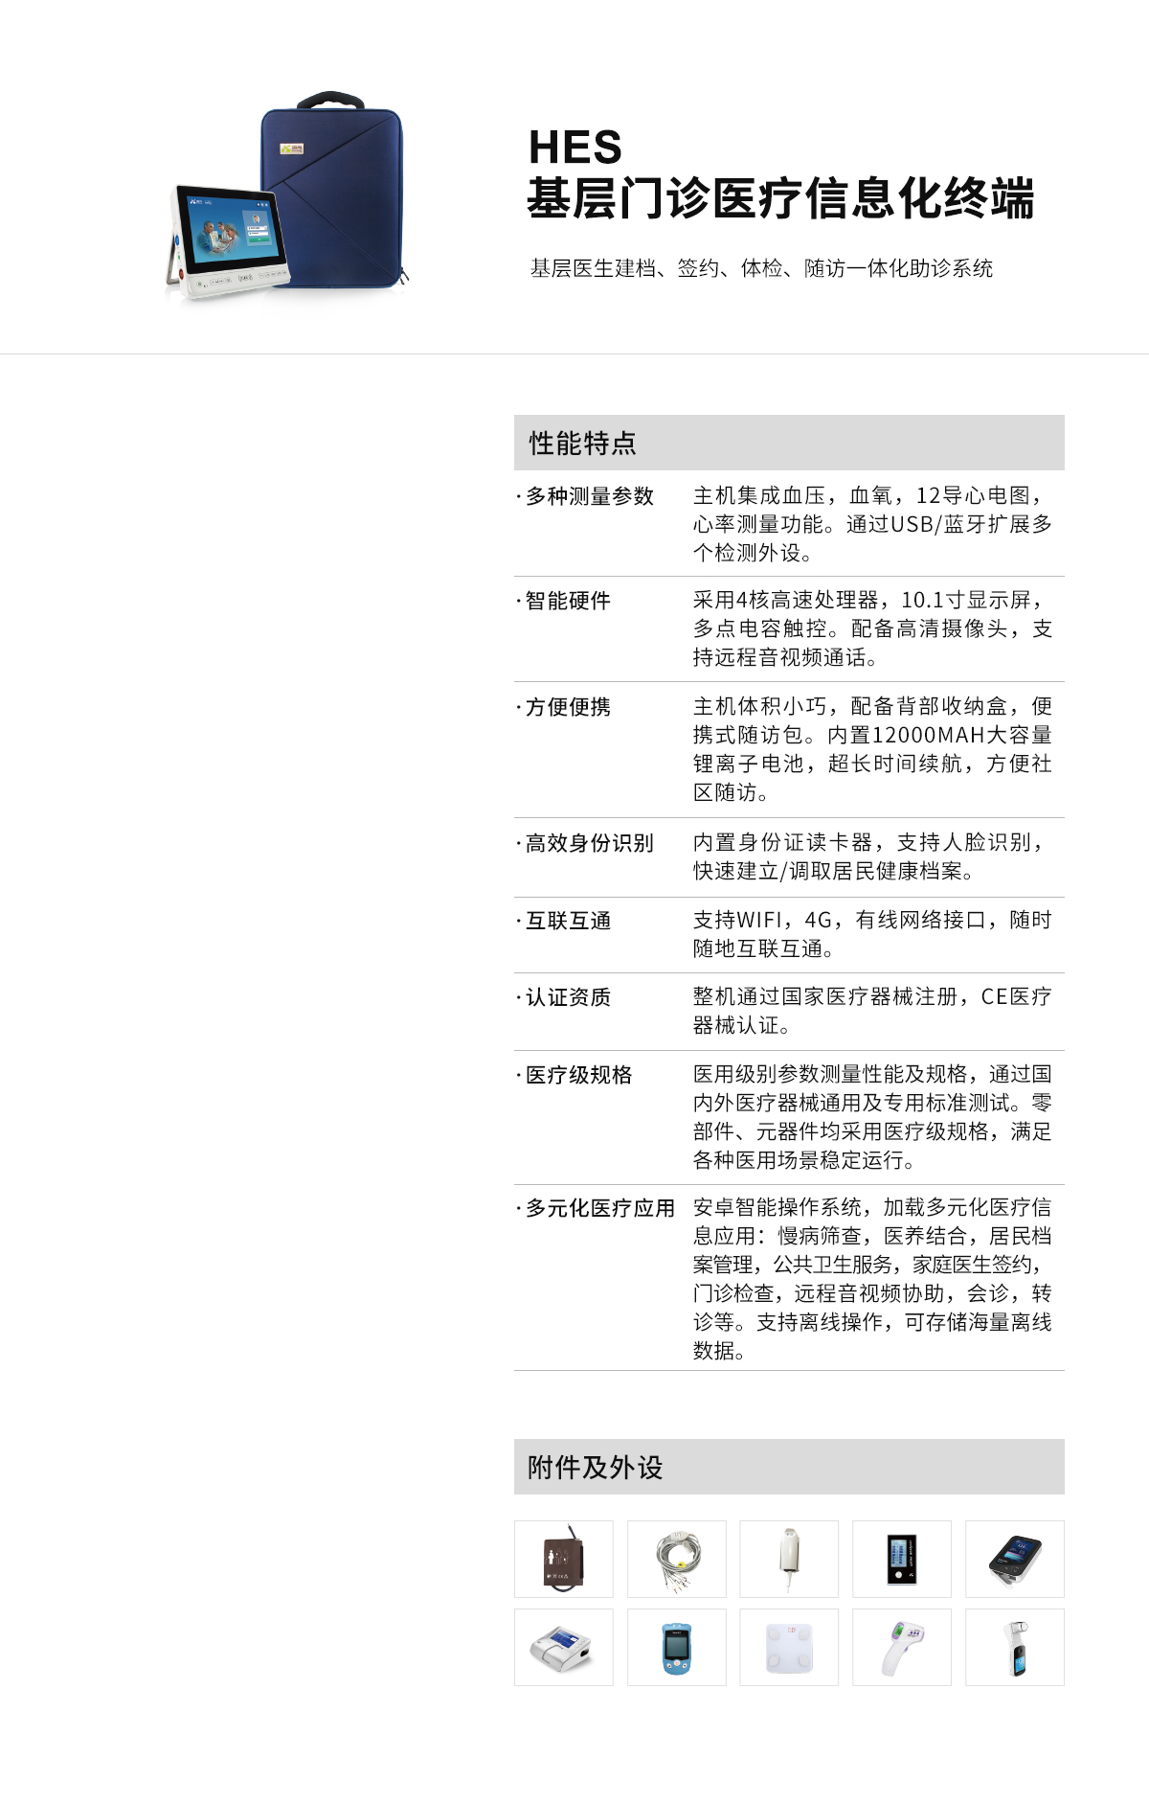

[[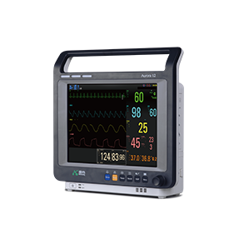](https://www.konsung.com/ProductDetail/6456447.html)](https://www.konsung.com/ProductDetail/6456447.html" \t "_blank)

[AURORA系列多参数监护仪](https://www.konsung.com/ProductDetail/6456447.html" \t "_blank)

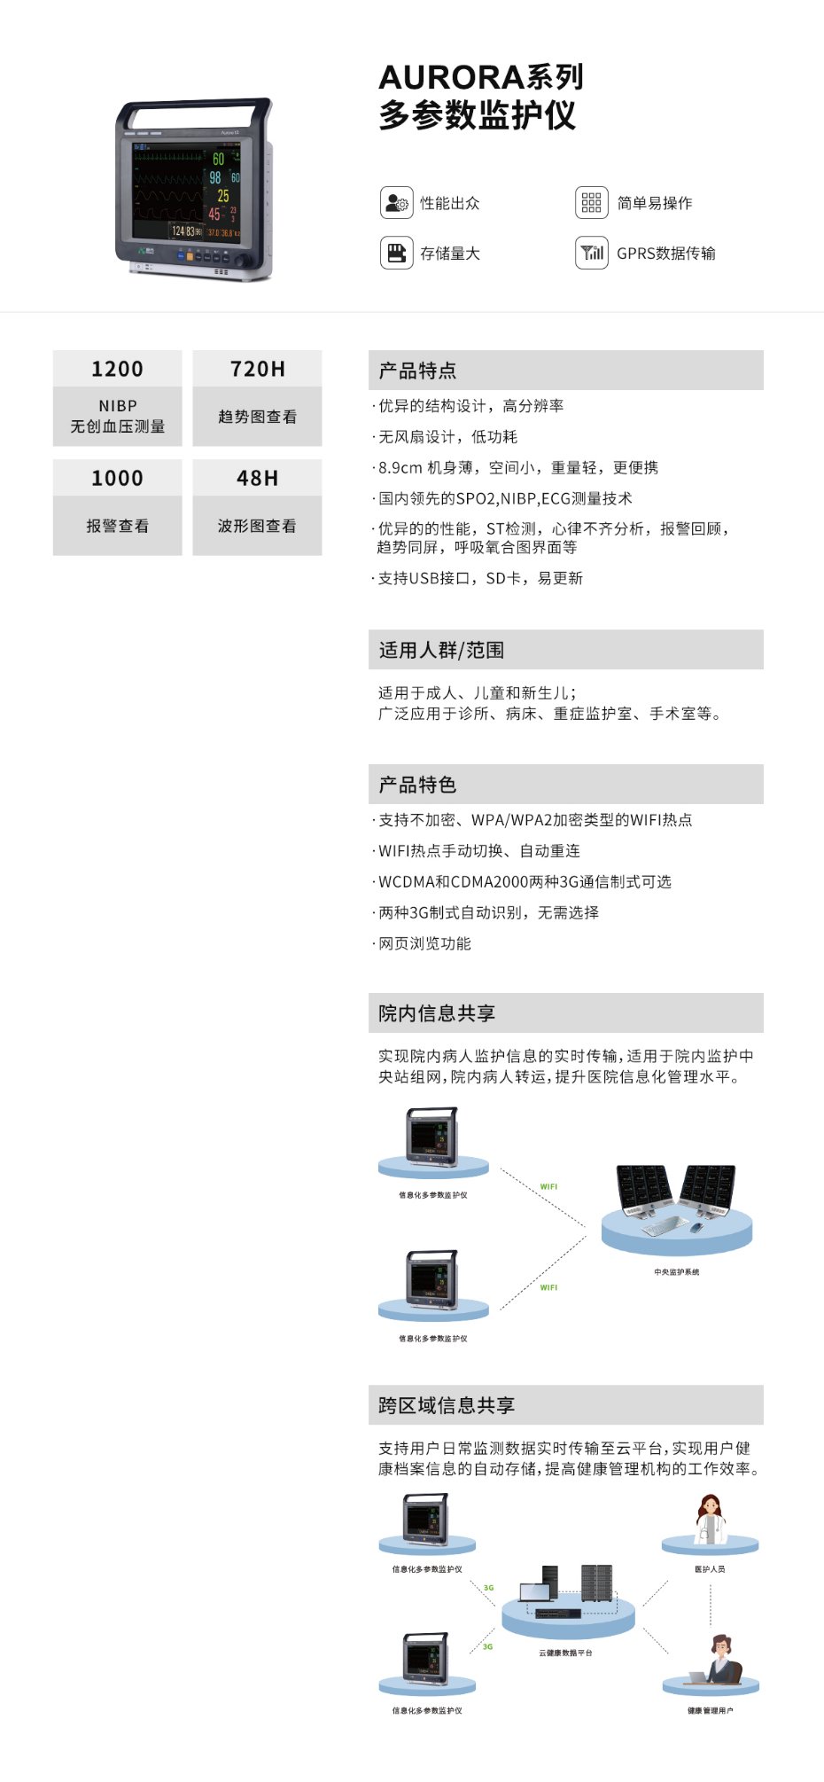

[体外诊断](https://www.konsung.com/TWZD)

[家用医疗](https://www.konsung.com/Content/2007326.html)

[医用设备](https://www.konsung.com/Product/475895.html)

[动物医疗](https://www.konsung.com/dwyl)

[胶体金](https://www.konsung.com/Product/499856.html)

[时间分辨免疫荧光](https://www.konsung.com/Product/499857.html)

[血红蛋白](https://www.konsung.com/Product/499858.html)

[尿液分析](https://www.konsung.com/Product/499859.html)

[医用制氧机](https://www.konsung.com/Product/501374.html)

[雾化器](https://www.konsung.com/Product/501375.html)

[多参数监护仪](https://www.konsung.com/ProductDetail/6758246.html)

[[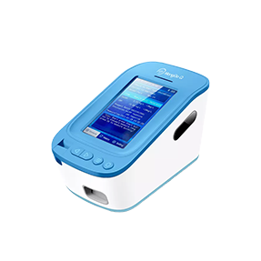](https://www.konsung.com/ProductDetail/6735518.html)](https://www.konsung.com/ProductDetail/6735518.html" \t "_blank)

[时间分辨荧光免疫分析仪](https://www.konsung.com/ProductDetail/6735518.html" \t "_blank)

[[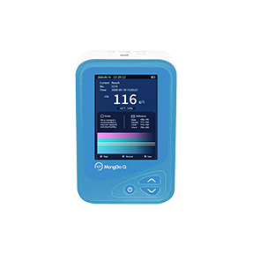](https://www.konsung.com/ProductDetail/6735567.html)](https://www.konsung.com/ProductDetail/6735567.html" \t "_blank)

[血红蛋白分析仪](https://www.konsung.com/ProductDetail/6735567.html" \t "_blank)

[[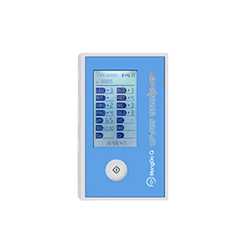](https://www.konsung.com/ProductDetail/6735566.html)](https://www.konsung.com/ProductDetail/6735566.html" \t "_blank)

[尿液分析仪](https://www.konsung.com/ProductDetail/6735566.html" \t "_blank)

[[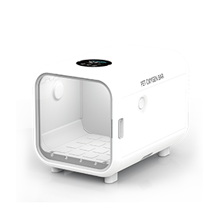](https://www.konsung.com/ProductDetail/6991769.html)](https://www.konsung.com/ProductDetail/6991769.html" \t "_blank)

[宠物氧舱](https://www.konsung.com/ProductDetail/6991769.html" \t "_blank)

[[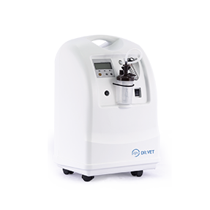](https://www.konsung.com/ProductDetail/6758208.html)](https://www.konsung.com/ProductDetail/6758208.html" \t "_blank)

[KSOC-3/3N/5/5N氧舱](https://www.konsung.com/ProductDetail/6758208.html" \t "_blank)

[[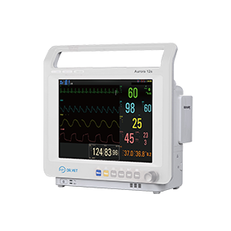](https://www.konsung.com/ProductDetail/6758246.html)](https://www.konsung.com/ProductDetail/6758246.html" \t "_blank)

[Aurora 10生命体征监测仪](https://www.konsung.com/ProductDetail/6758246.html" \t "_blank)

[[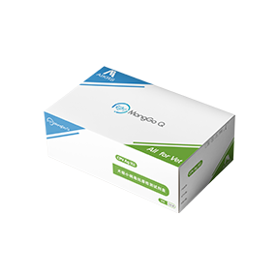](https://www.konsung.com/ProductDetail/6735164.html)](https://www.konsung.com/ProductDetail/6735164.html" \t "_blank)

[犬细小病毒抗原检测试剂盒CPV Ag (G)](https://www.konsung.com/ProductDetail/6735164.html" \t "_blank)

[[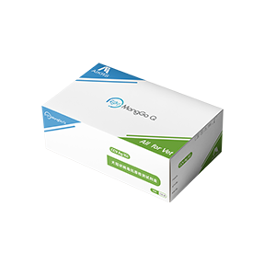](https://www.konsung.com/ProductDetail/6735163.html)](https://www.konsung.com/ProductDetail/6735163.html" \t "_blank)

[犬冠状病毒抗原检测试剂盒CCV Ag (G)](https://www.konsung.com/ProductDetail/6735163.html" \t "_blank)

[[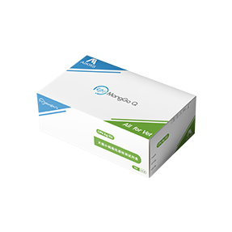](https://www.konsung.com/ProductDetail/6735155.html)](https://www.konsung.com/ProductDetail/6735155.html" \t "_blank)

[犬细小病毒抗原检测试剂盒CPV Ag (G)](https://www.konsung.com/ProductDetail/6735155.html" \t "_blank)

[[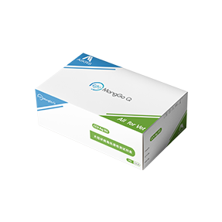](https://www.konsung.com/ProductDetail/6735154.html)](https://www.konsung.com/ProductDetail/6735154.html" \t "_blank)

[犬冠状病毒抗原检测试剂盒CCV Ag (G)](https://www.konsung.com/ProductDetail/6735154.html" \t "_blank)

[[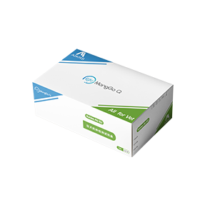](https://www.konsung.com/ProductDetail/6735150.html)](https://www.konsung.com/ProductDetail/6735150.html" \t "_blank)

[狂犬抗体检测试剂盒Rabies Ab (G)](https://www.konsung.com/ProductDetail/6735150.html" \t "_blank)

[[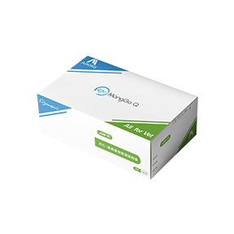](https://www.konsung.com/ProductDetail/6735168.html)](https://www.konsung.com/ProductDetail/6735168.html" \t "_blank)

[犬C-反应蛋白检测试剂盒cCRP (F)](https://www.konsung.com/ProductDetail/6735168.html" \t "_blank)

[[犬胰腺脂肪酶检测试剂盒CPL (F)](https://www.konsung.com/ProductDetail/6735173.html)](https://www.konsung.com/ProductDetail/6735173.html" \t "_blank)

[犬胰腺脂肪酶检测试剂盒CPL (F)](https://www.konsung.com/ProductDetail/6735173.html" \t "_blank)

[[犬孕酮检测试剂盒cProg (F)](https://www.konsung.com/ProductDetail/6735191.html)](https://www.konsung.com/ProductDetail/6735191.html" \t "_blank)

[犬孕酮检测试剂盒cProg (F)](https://www.konsung.com/ProductDetail/6735191.html" \t "_blank)

[[犬细小/犬瘟热/犬胰腺病毒抗体检测试剂盒CPV/CDV/CAV Ab (F)](https://www.konsung.com/ProductDetail/6735171.html)](https://www.konsung.com/ProductDetail/6735171.html" \t "_blank)

[犬细小/犬瘟热/犬胰腺病毒抗体检测试剂盒CPV/CDV/CAV Ab (F)](https://www.konsung.com/ProductDetail/6735171.html" \t "_blank)